**Project Design Phase-II**

**Data Flow Diagram & User Stories**

|  |  |
| --- | --- |
| Date | 03 October 2022 |
| Team ID | PNT2022TMID02498 |
| Project Name | Project – CUSTOMER CARE REGISTRY |
| Maximum Marks | 4 Marks |

**Data Flow Diagrams:**

A Data Flow Diagram (DFD) is a traditional visual representation of the information flows within a system. A neat and clear DFD can depict the right amount of the system requirement graphically. It shows how data enters and leaves the system, what changes the information, and where data is stored.

Example: DFD Level 0 (Industry Standard)

**Example:**

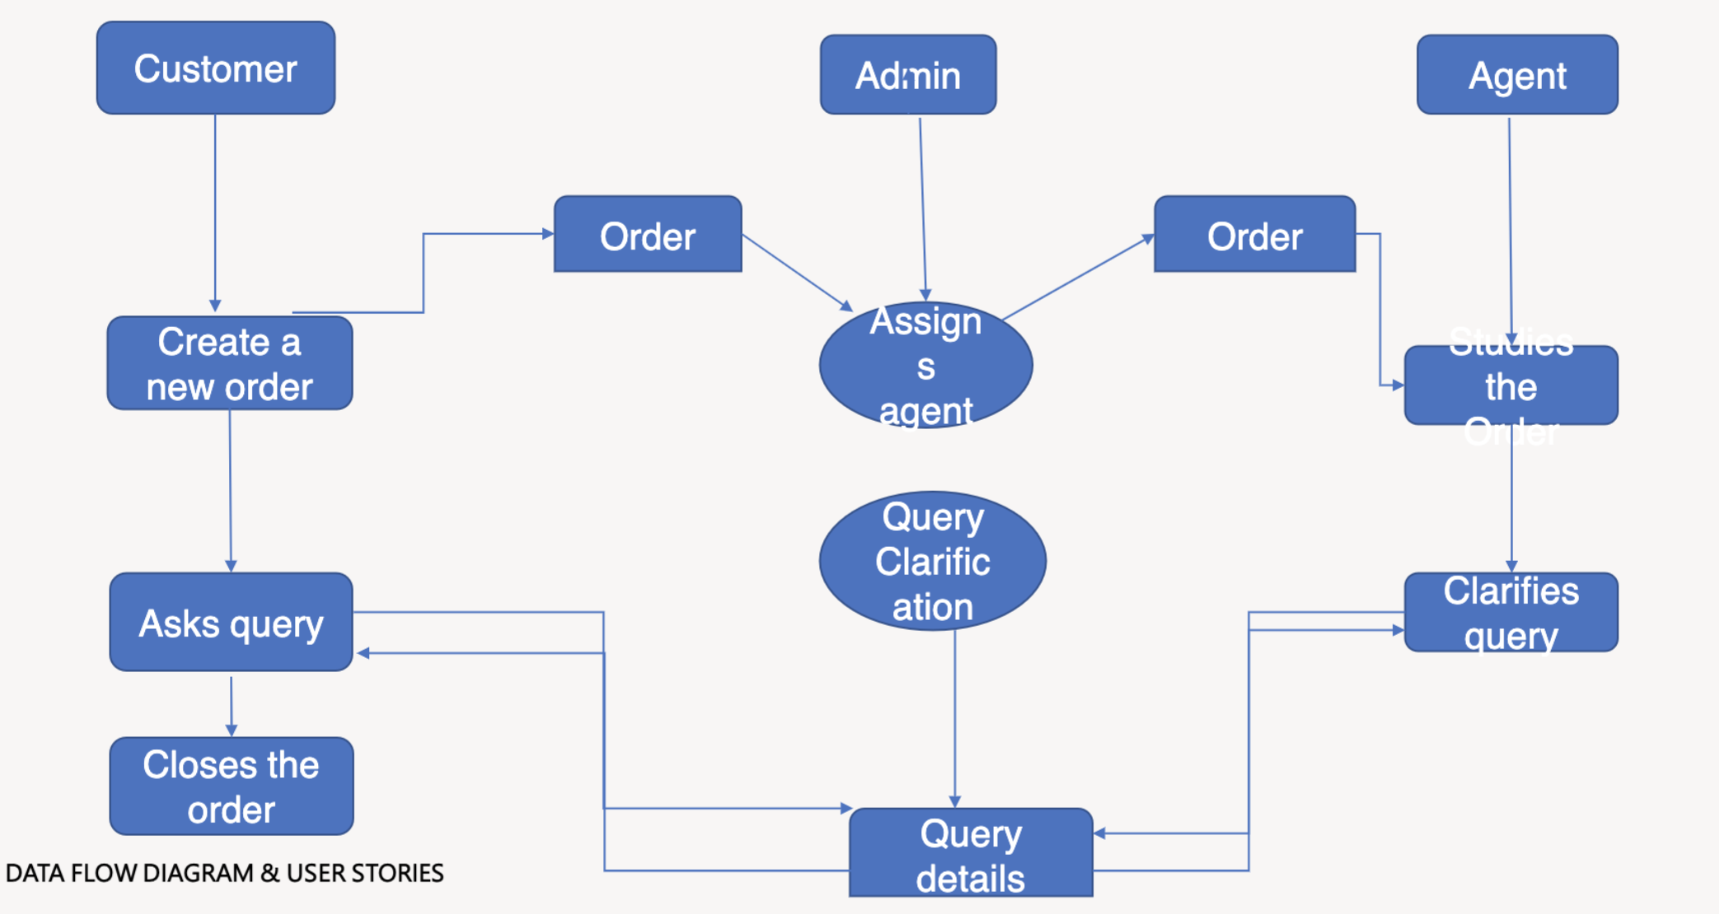

**User Stories**

Use the below template to list all the user stories for the product.

| **User Type** | **Functional Requirement (Epic)** | **User Story Number** | **User Story / Task** | **Acceptance criteria** | **Priority** | **Release** |
| --- | --- | --- | --- | --- | --- | --- |
| Customer (Mobile user) | Registration | USN-1 | As a user, I can register for the application by entering my email, password, and confirming my password. | I can access my account / dashboard | High | Sprint-1 |
|  | Login | USN-2 | As a customer, can login to the application I can access my by entering correct email and password. | I can access my account / dashboard | High | Sprint-1 |
|  | Dashboard | USN-3 | As a customer, I can see all the orders raised by me. | I get all the info needed in my dashboard. | Low | Sprint-2 |
|  | Order creation | USN-4 | As a customer, can place my order with the detailed description of my query | I can ask my query | Medium | Sprint-2 |
|  | Address Column | USN-5 | As a customer, I can have conversations with the assigned agent and get my queries clarified | My queries are clarified | High | Sprint-3 |
|  | Forgot Password | USN-6 | As a Customer ,I can reset my password by this option incase I forgot my old password | I get access to my account again | Medium | Sprint-4 |
|  | Order details | USN-7 | As a customer, I can see the current status of order | I get a better understanding | High | Sprint-4 |
| Customer  (web user) | Login | USN-1 | As an agent I can login to the application by entering correct email and password | I can access my account / dashboard | High | Sprint-3 |
|  | Dashboard | USN-2 | As an agent, I can see the order details assigned to me by admin | I can see tickets to which I could answer | High | Sprint-3 |
|  | Address Column | USN-3 | As an agent, I get to have conversations with the customer and clear his/her dobuts | I can clarify the issues | High | Sprint-3 |
|  | Forgot Password | USN-4 | As an agent I can reset my password by this option in case I forgot my old password | I get access to my account again | Medium | Sprint-4 |
| Admin  (Mobile user) | Login | USN-1 | As a admin ,I can login to the application by entering Correct email and password | I can access my account/dashboard | High | Sprint-1 |
|  | Dashboard | USN-2 | As an admin I can see all the orders raised in the entire system and Iot more | I can see assign agents by seeing those order | High | Sprint-1 |
|  | Agent creation | USN-3 | As an admin I can create an agent for clarifying the customer queries | I can create agents | High | Sprint-2 |
|  | Assignment agent | USN-4 | As an admin I can assign an agent for each order created by the customer | Enable agent to clarify the queries | High | Sprint-1 |
|  | Forgot Password | USN-5 | As an admin I can reset my password by this option in case I forgot my old password | I get access to my account | High | Sprint-1 |